**References:**

**PM Deployment:** <https://github.com/PM-Master/Policy-Machine/blob/master/Policy%20Machine%20Deployment%20Guide%20on%20Tomcat.pdf>

**Addendum:** On 19Jan18 Josh Roberts walked Ron through the additional (Neo4j) steps required for the Policy Machine to connect successfully to the Neo4j database. Josh then created this documentation:

1. Create a directory called "plugins" in the Neo4j/default.graphdb directory.
2. Get the correct version of the apoc jar file.  It is important to get the correct version that matches your Neo4j version.  Go to <https://github.com/neo4j-contrib/neo4j-apoc-procedures#version-compatibility-matrix> and find your version of neo4j and proceed to download the jar file of the corresponding apoc version.
3. Place this jar file in the plugins directory you created in step 1.  To verify the jar file is in the correct location, in the neo4j splash screen go to options->Plugins and Extensions and click "open".  This should open the plugins directory and you should see the apoc jar file you just downloaded.
4. Add the following line of code to the neo4j.conf file.  This file can be found by going to the neo4j splash screen->options->Database Configuration and clicking the "edit" button.
5. dbms.security.procedures.unrestricted=apoc.*
6. Restart the neo4j server
7. If there are no errors starting neo4j, go to the Policy Machine Configuration page and reconnect to neo4j.  This will connect to the database and load any nodes and relationships into the Policy Machine data structure.

**Neo4j Default *database*:**

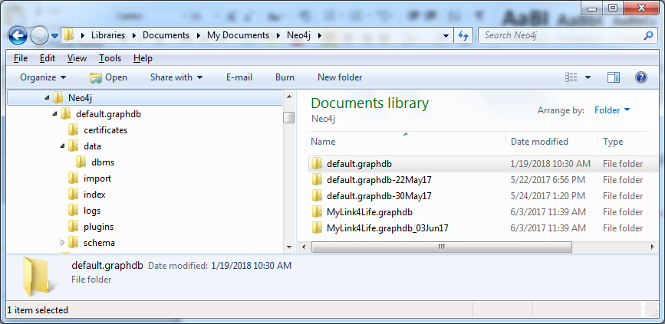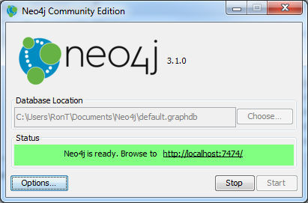

Per addendum instruction #1, the plugins folder here must be hand-created.

**Related paths (“Options” pop-up) critical to Neo4j:**

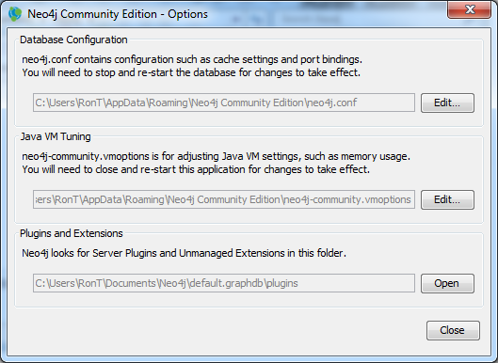

**Config install:**

Per instruction #4 above, this is the path for neo4j.conf.

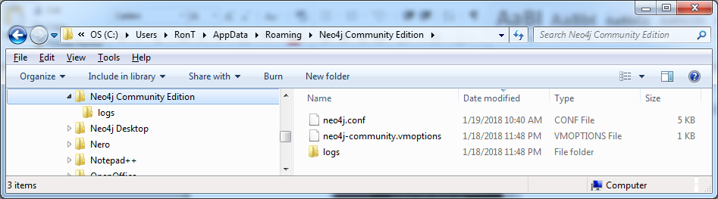

**Neo4j binary (this *plugins* folder is not the *plugins* for the database [above]):**

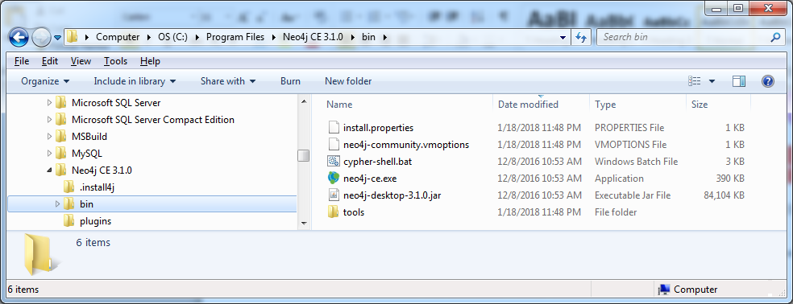

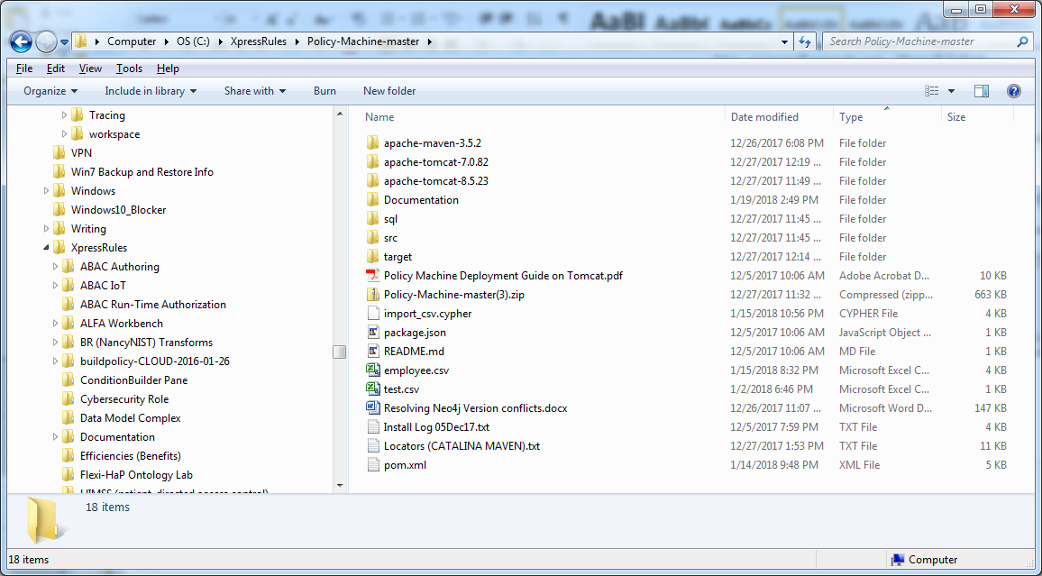**Root directory of Policy-Machine:**